**Sustainable Outreach And Universal**

**Leadership (SOUL) Limited**

**Software Requirement Specification (SRS)**

Of

**Academics module**

For Implementation of

**Campus Management Software**

at

**World Skill Center (WSC)**

**Department - SOS**

**Table of Content**

A. Abstract 3

B. Introduction 3

C. Definition, Acronyms and Abbreviations 3

D. Overview of the Document 3

E. Scope of Education Module 4

F. WSC Student Academics Process Flow 5

G. Process Flow Description 5

H. List of Screen and their descriptions 6

I. Academics 8

1. Academic Home Screen 8

1.1 Student Group 8

1.2 Course Scheduling Tool 12

1.3 Course Schedule 14

1.4 Student Attendance Tool 16

1.5 Student Attendance 18

1.6 Student Leave Application 19

1.7 Mentor Allocation 21

1.8 Mentee Communication 23

1.9 Mentor Communication 24

1.10 Assignment 26

1.11 Assignment Upload 28

# Abstract

Software Requirements Gathering is one of the first phases of system development. This phase results in the Software Requirements Specification (SRS) document, which must contain a complete, concise, high-quality description of the system being considered.

# Introduction

The World Skill Center (WSC) is a premier advanced skill training institute established by the Government of Odisha, Skill Development and Technical Education Department, through the Odisha Skill Development Authority (OSDA). The WSC will impart advanced skill training in eight trades from engineering and service sectors. WSC caters primarily to induct the best talent from ITIs and Polytechnics and train them to become globally employable in emerging areas such as "Industry 4.0". WSC is housed in a state-of-the-art, 18-storey, air-conditioned building with nearly half a million square feet of space in the heart of capital city of Bhubaneswar.

With the Implementation of campus management software for WSC the goal is to streamline the operations and functions of the campus by integrating various processes, such as admissions, course registration, academic progress tracking, and financial management, HRMS, Procurement and Inventory management, etc into a unified system. The implementation also aims at providing a user-friendly interface for all stakeholders, making it easier for them to access the necessary information and complete their tasks with ease. The modules to be covered during the implementation of the software includes:

|  |  |
| --- | --- |
| Students Management Modules | Infrastructure Management |
| Academic System | Finance and Accounting System |
| Procurement & Inventory Management | Training and Placement |
| Human Resources Management System | Application Integration |

# Definition, Acronyms and Abbreviations

The following table explains the terms and abbreviations used in the document:

|  |  |
| --- | --- |
| **Abbreviation** | **Description** |
| SRS | Software Requirements Specification |
| SLCM | Student Life Cycle Management |
| R | Rename - When a field is Renamed |
| N | New - When a New field is Added |
| D | Delete - When an Existing field is Deleted |
| NA | Not Applicable |

# Overview of the Document

This requirement document provides a detailed overview of the functional requirements of a project. It serves as a communication tool between stakeholders, including developers, project managers, and end-users. The purpose of this requirement document is to define and document the project's objectives, scope, and expectations, and to ensure that all stakeholders have a clear understanding of what the project entails.

This document covers all the functional requirements of the **Academic Education module** of ERP Product. This module helps in organizing the entire academic of education set-up, such as Student Database, Trainers Information, Student Attendance, Time table creation, Mentor Mentees communication, Assignments, etc.

# Scope of Education Module

* Class occurrence monitoring
* Faculty Workload / Lesson Plan  ▪
* Class Attendance of students (Face recognition or any other automated mode).    ▪
* Results Analysis after declaration of results by WSC ▪
* Students Feedback mechanism on quality of teaching learning ▪ Internship, Training, Apprentice ▪
* Students Profile: Personal Information, Contact Details, Academic Details.
* Re-Admission Process after discontinuing in studies
* Issue of Identity Card
* Students Back paper tracking etc.
* Students Profile.  :Personal Information, Contact Details, Academic Details ▪
* Biometric Attendance (Face recognition) ▪
* Hostel Management (Hostel seat allotment, attendance, fees etc) ▪
* Scholarships.  ▪
* Rewards and achievements.  ▪
* Students’ Evaluation/remarks of Faculty.  ▪
* Students Exams records of all 6 semesters ▪ Parent Enquiry/Alert/Messaging Management.  ▪
* Messaging System  ▪
* Students Grievance System etc.

Following functionalities are covered in this SRS document:

* **Courses and Subjects, Timetable preparation and management **
* **Class Attendance of students**
* **Class occurrence monitoring**

# WSC Student Academics Process Flow

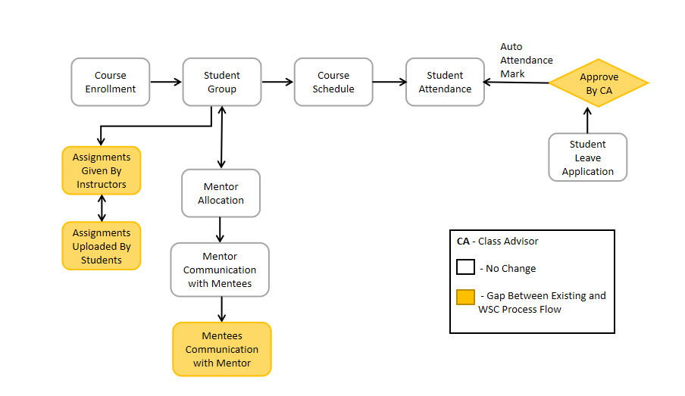

# Process Flow Description

**Student Group**

The Student Group allows you to create a group of students for different classes for the ongoing Academic Year.

**Time Table (Course Schedule)**

A Time table is a specialized functional area or a division where a user can see day wise modules, their class time, trainer details, rooms, etc.

**Timetable Scheduling Tool**

The Timetable Scheduling Tool allows a user to create Timetable in bulk for the particular module.

**Student Attendance**

The Student Attendance allows you to keep track and mark the attendance of a student for a day. Attendance records can be created against students on a daily basis.

**Student Attendance Tool**

The Student Attendance Tool allows user to bulk update the Attendance for Students based on Student Group and Course Schedule.

**Student Leave Application**

The Student Leave Application allows you to keep a track of leaves for a Student.

**Mentor Allocation**

Mentor Allocation is a process in which Mentors (Instructors) are allocated to different student groups or students on various basis. It can either be a hostel mentor allocation or program wise allocation.

**Mentees Communication**

As in any relationship where information is being shared on an on-going basis, you and your mentees need to Interact and communicate effectively.

**Mentor Communication**

In Mentor Communication, mentors or trainers can communicate with their respective students to share different information and other activities.

**Assignment Given**

In Assignment Screen Trainers can easily provide assignment to their respective students, so that it gives a strong bonding between the students and the trainers.

**Assignment Upload**

Assignment Upload Screen Students can easily upload their assignment and it will securely go to their respective trainers.

# List of Screen and their descriptions

The following tables lists the pages used in Academics module :

|  |  |  |
| --- | --- | --- |
| **Sl no** | **Screen Name** | **Description** |
| 1 | Student Group | The Student Group allows you to create a group of students for different classes for the ongoing Academic Year. |
| 2 | Timetable Scheduling Tool | The Timetable Scheduling Tool allows a user to create Timetable in bulk for the particular module. |
| 3 | Course Schedule | A Time table is a specialized functional area or a division where a user can see day wise modules, their class time, trainer details, rooms, etc. |
| 4 | Student Attendance Tool | The Student Attendance Tool allows user to bulk update the Attendance for Students based on Student Group and Course Schedule. |
| 5 | Student Attendance | The Student Attendance allows you to keep track and mark the attendance of a student for a day. Attendance records can be created against students on a daily basis. |
| 6 | Student Leave Application | The Student Leave Application allows you to keep a track of leaves for a Student. |
| 7 | Mentor Allocation | Mentor Allocation is a process in which Mentors (Instructors) are allocated to different student groups or students on various basis. It can either be a hostel mentor allocation or program wise allocation. |
| 8 | Mentor Communication | In Mentor Communication, mentors or trainers can communicate with their respective students to share different information and other activities. |
| 9 | Mentee Communication | As in any relationship where information is being shared on an on-going basis, you and your mentee need to Interact and communicate effectively. |
| 10 | Assignment Given | In Assignment Screen Trainers can easily provide assignment to their respective students, so that it gives a strong bonding between the students and the trainers. |
| 11 | Assignment Upload | In Assignment Upload Screen Students can easily upload their assignment and it will securely go to their respective trainers. |

# Academics

## Academic Home Screen

Master screens are the core screens / data that are absolutely essential for running operations within the Academics module, while the transactional screens are those which are used on a daily or regular basis.

Below is the complete workspace for Academics:

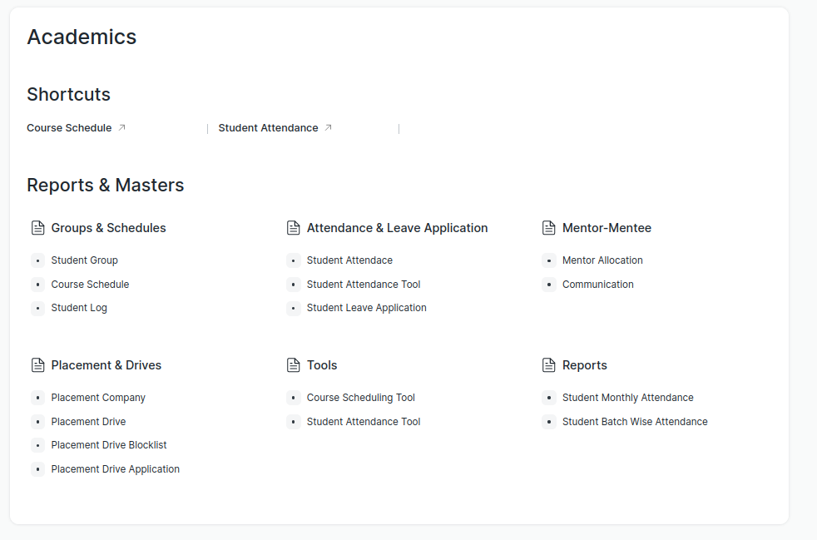

Figure 1 : Academic Home Screen

## Student Group

**General Description**

The following table describes overall information about this screen:

|  |  |
| --- | --- |
| **Description** | 1. Student group is a collection of students who share common characteristics or attributes. 2. These characteristics may include factors such as the students' academic level, course of study, program of study, or other specific criteria used to group students together 3. The Student Group allows you to create a group of students for different classes for the ongoing Academic Year. 4. User will fill out the necessary information for the student group, such as a name for the group, batch, module, mentor-mentees and the criteria that will be used to add students to the group for creation of student group. |
| **Navigation** | Home > Academics > Group & Schedules > Student Group |
| **Pre-requisites** | 1. Student 2. Program Enrollment 3. Course Enrollment 4. Student Batch Name 5. Student Category 6. Instructor |

**Screenshot**

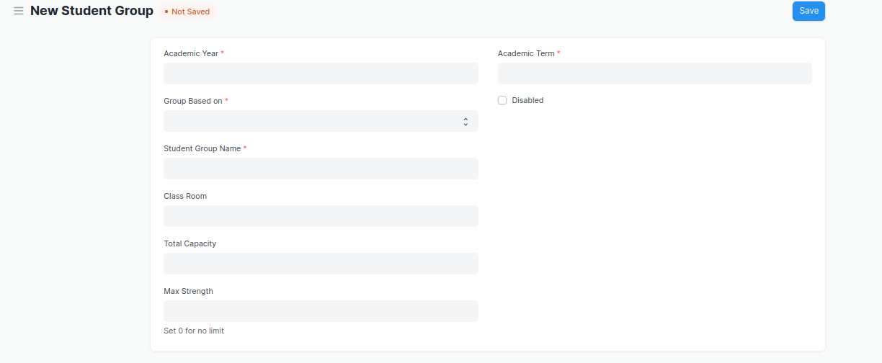

Figure 2 :Student Group screen

**Field List**

The following table describes the UI fields present in this screen :

|  |  |  |  |  |  |  |
| --- | --- | --- | --- | --- | --- | --- |
| **ID** | **Field Name** | **Field Type** | **Mandatory** | **Validation/Action** | **Remarks** | **R/N/D** |
| 1 | Academic Year | Link Field | Yes | Value Fetched From the Academic Year list and will show in a drop down. User will select one of them. |  |  |
| 2 | Group Based on | Drop down | Yes | Options : Batch Course Activity  Mentor Communication |  | 1. Combined Course   (D) Exam Declaration |
| 3 | Student Group | Text | Yes | User will give input |  |  |
| 4 | Max Strength | Number |  | User will give input |  |  |
| 5 | Academic Term | Link Field |  | Link Field to Academic Term Screen and filtered applied w.r.t Academic Year |  |  |
| 6 | Program | Link Field |  | Value will be fetched from Program list in a drop down.User will select one value. |  | ( R ) Course |
| 7 | Batch | Link Field |  | Link Field to Batch Screen |  |  |
| 8 | Student Category | Link Field |  | Value will be fetched from Student Category list in drop down. User will select one value. |  |  |
| 9 | Course | Link Field |  | Value will be fetched from course list , and course field will be visible when a user select group based on courses. |  | ( R ) Module |
| 10 | Disabled | Check box |  | If Checked, the student group record will not be able to visible in any respective transaction |  |  |
| 11 | Get Students | Button |  | 1. User will click the Get Students Button.   2. On click list of students with respect to the course will auto fetched in the students table |  |  |
| 12 | **Students** | Table |  | On clicking Get students button, all the students will be fetched according to the inputted parameters. And the description of the table is given below. |  |  |
| 13 | **Instructors** | Table |  | 1. Instructor list need to be selected according to the inputted parameters . 2. when student group based on course selected then only those instructor list will be on drop down w.r.t. the entered course. 3. Description of the table is given below. |  | ( R )Trainer |

|  |  |  |  |  |  |  |
| --- | --- | --- | --- | --- | --- | --- |
| **Student Group Student** | | | | | | |
| **ID** | **Field Name** | **Field Type** | **Validation/Action** | **Mandatory** | **Remarks** | **R/N/D** |
| 1 | Student | Link Field | Those students will come who are belongs to the particular course, semester and In group based up on activity and mentor communication, user needs to manually entered the students. | Yes |  |  |
| 2 | Student Name | Text | Student Name will auto fetched when student Id fetched in student Field |  |  |  |
| 3 | Group Roll Number | Number | Roll will auto create |  |  |  |
| 4 | Active | Check box | If unchecked then this Student will not visible in any transaction |  |  |  |
| 5 | Gender | Link Field | Link Field to Gender Screen | Auto Fetch from student screen |  |  |
| 6 | Category | Link Field | Link Field to Student Category Screen | Auto Fetch from student screen |  |  |

|  |  |  |  |  |  |  |
| --- | --- | --- | --- | --- | --- | --- |
| **Student Group Instructor** | | | | | | |
| **ID** | **Field Name** | **Field Type** | **Validation/Action** | **Mandatory** | **Remarks** | **R/N/D** |
| 1 | Instructors | Link Field | Value will fetch from Instructor list.User will select value. | Yes |  | (R) Trainer |
| 2 | Instructor Name | Read only | After selecting the instructor id , this value will be auto filled. |  |  | (R) Trainer Name |
| 3 | Course | Link Field | If course wise group created, then those course will come whose name selected in the above course field | Yes |  | (R) Module |

**Users: Roles and Permissions**

The following table describes the users and their roles and permissions for the screens :

|  |  |  |  |  |  |  |  |  |
| --- | --- | --- | --- | --- | --- | --- | --- | --- |
| **ID** | **Role** | **Read** | **Write** | **Create** | **Delete** | **Submit** | **Cancel** | **Amend** |
| 1 | Student | Yes | No | No | No | NA | NA | NA |
| 3 | Education Admin | Yes | Yes | Yes | Yes | NA | NA | NA |
| 4 | Instructor | Yes | No | No | No | NA | NA | NA |

## Course Scheduling Tool

**General Description**

The following table describes overall information about this screen:

|  |  |
| --- | --- |
| **Description** | The Course Scheduling Tool allows a user to create Course Schedules in bulk for the particular Course. |
| **Navigation** | Home > Academics > Tools > Course Scheduling Tool |
| **Pre-requisites** | 1. Student Group  2. Instructor  3. Course  4. Class  5. Classroom |
| **Existing Screen Name** | Course Scheduling Tool |
| **New Screen Name** | Timetable Scheduling Tool |

**Screenshot**

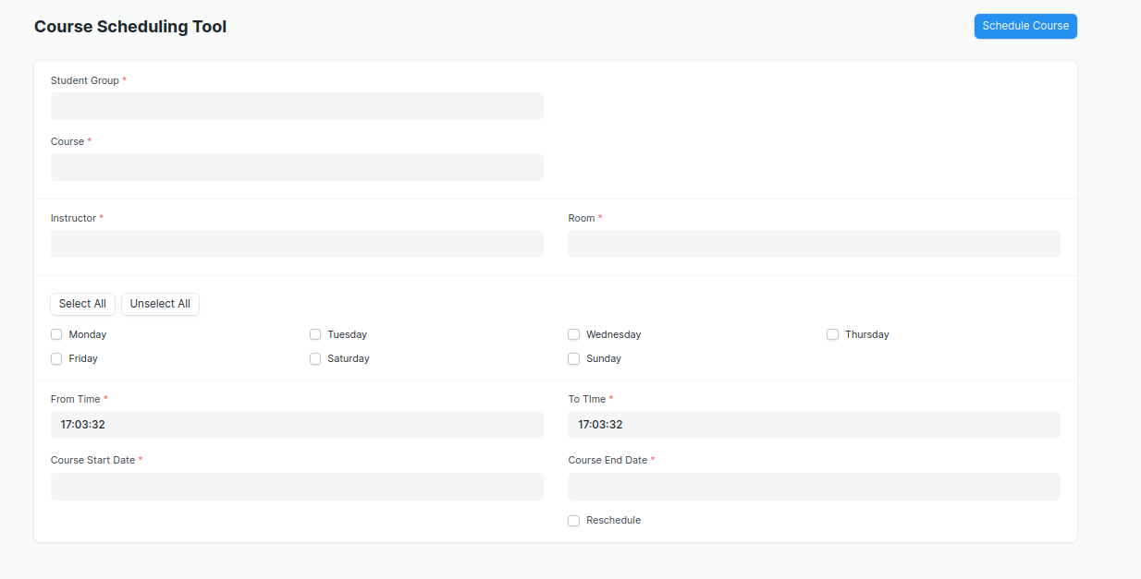

Figure 8 : Timetable Scheduling Tool Screen

**Field List**

The following table describes the UI fields present in this screen :

|  |  |  |  |  |  |  |
| --- | --- | --- | --- | --- | --- | --- |
| **ID** | **Field Name** | **Field Type** | **Mandatory** | **Validation/Action** | **Remarks** | **R/N/D** |
| 1 | Student Group | Link Field | Yes | Value will be fetched from Student Group List, User will select one of them |  |  |
| 2 | Course | Link Field | Yes | Value will be fetched from course list.User will select one. |  | ( R ) Module |
| 3 | Program | Link Field |  | Value will be fetched from  Program list, user will select. |  | ( R ) Course |
| 4 | Academic Year | Link Field |  | Value will be fetched from  Academic year list,user  Will select one. |  |  |
| 5 | Academic Term | Link Field |  | Based on the academic year,  Academic term will show in a drop down. User will select. |  |  |
| 6 | Instructor | Link Field | Yes | Value will be fetched from  Instructor list,user will select one. |  | ( R ) Trainer |
| 7 | Instructor Name | Read Only |  | Automatically filled up after  Selecting Instructor. |  | ( R ) Trainer Name |
| 8 | Room | Link Field | Yes | Value will be fetched from  Room list, user will select one. |  |  |
| 9 | From Time | Time | Yes | User will select time. |  |  |
| 10 | Course Start Date | Date | Yes | Start date should be before the End Date |  | ( R ) Module Start Date |
| 11 | To Time | Time | Yes | User will select time. |  |  |
| 12 | Course End Date | Date | Yes | Course End date should be greater then Course Start Date |  | ( R ) Module End Date |

1. User will Click on ‘Schedule Course’ Button.

**\*\*Note: The system should create the course schedules if the classroom and Instructor are**

**available and there is no conflict for the selected Student Group with other course**

**schedules.**

**Rescheduling**

1. User can reschedule the course schedules created.

2. User will Check the ‘Reschedule Checkbox and then click on ‘Schedule Course’.

3. System should delete the existing Course Schedules for the particular Course within the

mentioned Start Date and End Date and should create a new Course Schedules.

**\*\*The entries for all the Course Scheduling Tools should created in the Course Schedule**

**Document. \*\***

**Users: Roles and Permissions**

The following table describes the users and their roles and permissions for the screens :

|  |  |  |  |  |  |  |  |  |  |
| --- | --- | --- | --- | --- | --- | --- | --- | --- | --- |
| **ID** | **Role** | **Select** | **Read** | **Write** | **Create** | **Delete** | **Submit** | **Cancel** | **Amend** |
| 1 | Admin | Yes | Yes | Yes | Yes | Yes | NA | NA | NA |
| 2 | Instructor | Yes | Yes | Yes | Yes | Yes | NA | NA | NA |

## Course Schedule

**General Description**

The following table describes overall information about this screen:

|  |  |
| --- | --- |
| **Description** | 1. A course schedule is a specialized functional area or a division within the Groups and schedule. 2. The Course Schedule can be used for scheduling a particular course by the User. 3. Using this feature, a timetable can be created for a University, wherein each slot will be scheduled via Course Schedule. |
| **Navigation** | Home > Academics > Group & Schedules > Course Schedule |
| **Pre-requisites** | 1. Student Group  2. Instructor  3. Course  4. Class  5. Classroom |
| **Existing Screen Name** | Course Schedule |
| **New Screen Name** | Timetable |

**Screenshot**

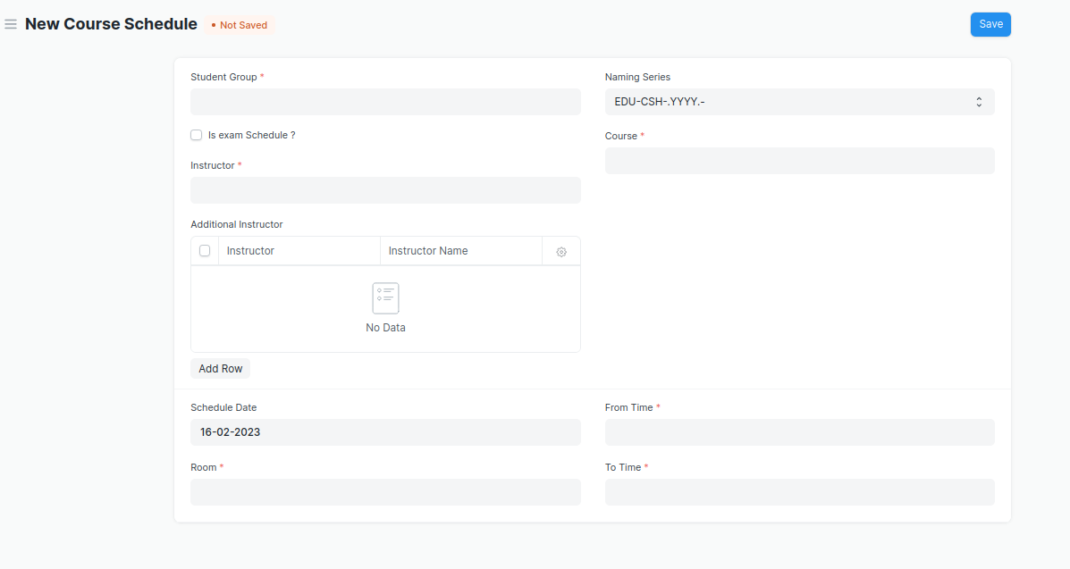

Figure 4 : Timetable Screen

**Field List**

The following table describes the UI fields present in this screen :

|  |  |  |  |  |  |  |
| --- | --- | --- | --- | --- | --- | --- |
| **ID** | **Field Name** | **Field Type** | **Validation/Action** | **Mandatory** | **Remarks** | **R/N/D** |
| 1 | Student Group | Link Field | Value will be fetched from student group list in a drop down. User will select . | Yes |  |  |
| 2 | Instructor | Link Field | Value will be fetched from the child table (Student Group Instructor) of the selected instructor | Yes |  | ( R ) Trainer |
| 3 | Instructor Name | Read only | Auto fetch instructor name from the above instruction field |  |  | ( R ) Trainer Name |
| 4 | **Additional Instructor** | **Table** |  |  | This table is described below |  |
| 5 | Program | Link Field | Value will be fetched from the selected student group. |  |  | ( R ) Course |
| 6 | Course | Link Field | Value will be fetched from selected student group. | Yes |  | ( R ) Module |
| 7 | Schedule Date | Date | User will enter the schedule date of the course |  |  |  |
| 8 | Room | Link Field | Value will be fetched from the room list in a drop down . user will select. | Yes |  |  |
| 9 | From Time | Time | User will select the time. | Yes |  |  |
| 10 | To Time | Time | User will select the time. | Yes |  |  |

**Note: Course Scheduling Tool can be used for bulk scheduling of a course. **

|  |  |  |  |  |  |  |
| --- | --- | --- | --- | --- | --- | --- |
| **ID** | **Field Name** | **Field Type** | **Validation/Action** | **Mandatory** | **Remarks** | **R/N/D** |
| 1 | Instructor | Link Field | Value will be fetched from the child table (Student Group Instructor) of the selected instructor | Yes |  | ( R ) Trainer |
| 2 | Instructor Name | Read only | Auto fetch instructor name from the above instruction field |  |  | ( R ) Trainer Name |

**Users: Roles and Permissions**

The following table describes the users and their roles and permissions for the screens :

|  |  |  |  |  |  |  |  |  |  |
| --- | --- | --- | --- | --- | --- | --- | --- | --- | --- |
| **ID** | **Role** | **Select** | **Read** | **Write** | **Create** | **Delete** | **Submit** | **Cancel** | **Amend** |
| 1 | Academics Head | No | Yes | Yes | Yes | Yes | NA | NA | NA |
| 2 | Education Admin | Yes | Yes | Yes | Yes | Yes | NA | NA | NA |
| 3 | Instructor | No | Yes | Yes | Yes | No | NA | NA | NA |
| 4 | Student | Yes | Yes | Yes | Yes | Yes | NA | NA | NA |
| 5 | Academic Management Group | Yes | Yes | No | No | No | NA | NA | NA |

## Student Attendance Tool

**General Description**

The following table describe overall information about this screen:

|  |  |
| --- | --- |
| **Description** | The Student Attendance Tool allows user to bulk update the Attendance for Students based on Student Group and Course Schedule. |
| **Navigation** | Home > Academics > Tools > Student Attendance Tool |
| **Pre-requisites** | 1. Student  2. Course Schedule  3. Student Group |

**Screenshot**

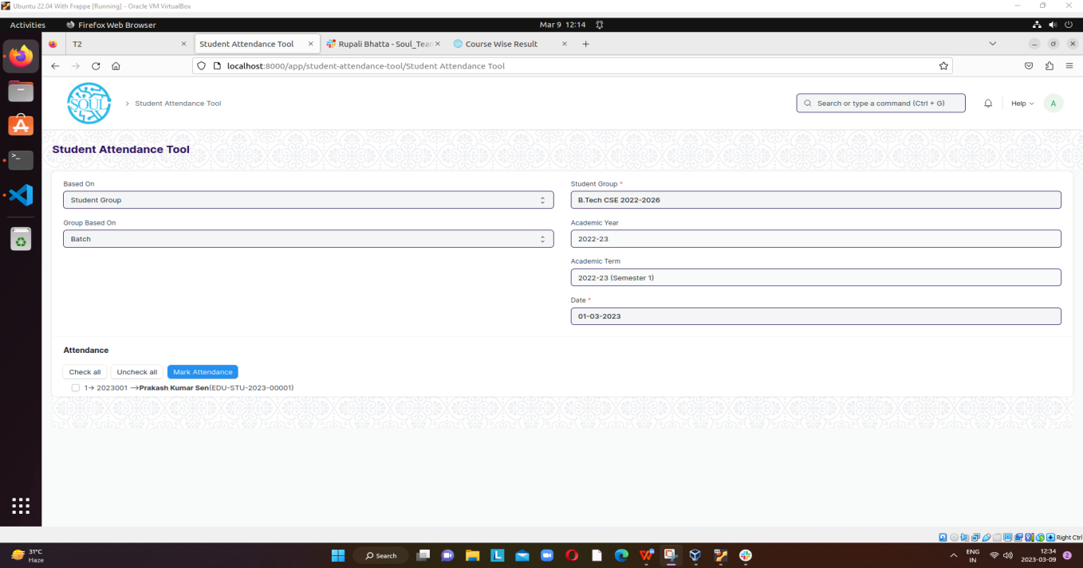

Figure 9 : Student Attendance Screen

**Field List**

The following table describes the UI fields present in this screen :

|  |  |  |  |  |  |  |
| --- | --- | --- | --- | --- | --- | --- |
| **ID** | **Field Name** | **Field Type** | **Mandatory** | **Validation/Action** | **Remarks** | **R/N/D** |
| 1 | Based On | Dropdown |  | Options : Student Group Course Schedule |  |  |
| 2 | Group Based On | Dropdown |  | Options :Batch Course Activity |  |  |
| 3 | Student Group | Link Field | Yes | Value will be fetched from  Student group list.User  Will select one. |  |  |
| 4 | Academic Year | Link Field |  | Value will be fetched from  Academic year,user will  Select one. |  |  |
| 5 | Academic Term | Link Field |  | Value will be fetched  Based on selected academic year. |  |  |
| 6 | Course Schedule | Link Field |  | Value will be fetched based on course schedule list. |  | ( R ) Module Schedule |
| 7 | Date | Date | Yes | User will select the date, Date should not be the future date |  |  |
| 8 | Check All | Button |  | On Click all the students attendance will marked automatically |  |  |
| 9 | Uncheck All | Button |  | On Click all the students attendance will unchecked automatically |  |  |
| 10 | Mark Attendance | Button |  | On click a popup will come having the status of number of student absent and present |  |  |
| 11 | Student List | Table |  |  |  |  |
| **Student List Table** | | | | | | |
| **ID** | **Field Name** | **Field Type** | **Mandatory** | **Validation/Action** | **Remarks** | **R/N/D** |
| 1 | Student Id | Link Field |  | Auto fetch on the basis of Student Group | Need to be read only field |  |
| 2 | Student Name | Text |  | Auto fetch on the basis of Student Group | Need to be read only field |  |
| 3 | Roll Number | Text |  | Auto fetch on the basis of Student Group | Need to be read only field |  |
| 4 | On Leave | Dropdown |  | Options:  Yes  No  Auto fetch when a student leave application is approved or rejected | Need to be read only field |  |

\*\***Note**:

* **Reminder mail will be send after two week to the trainer and head of the department if an attendance is not marked for a particular class.**

**Users: Roles and Permissions**

The following table describes the users and their roles and permissions for the screens :

|  |  |  |  |  |  |  |  |  |  |
| --- | --- | --- | --- | --- | --- | --- | --- | --- | --- |
| **ID** | **Role** | **Select** | **Read** | **Write** | **Create** | **Delete** | **Submit** | **Cancel** | **Amend** |
| 1 | Admin | Yes | Yes | Yes | Yes | Yes | NA | NA | NA |
| 2 | Instructor | Yes | Yes | Yes | Yes | Yes | NA | NA | NA |
| 3 | Hostel Admin | Yes | Yes | Yes | Yes | Yes | NA | NA | NA |

## Student Attendance

**General Description**

The following table describes overall information about this screen:

|  |  |
| --- | --- |
| **Description** | The Student Attendance allows you to keep track and mark the attendance of a student for a day. Attendance records can be created against students on a daily basis. |
| **Navigation** | Home > Academics > Attendance and Leave Application > Student Attendance |
| **Pre-requisites** | 1. Student  2. Course Schedule  3. Student Group |

**Screenshot**

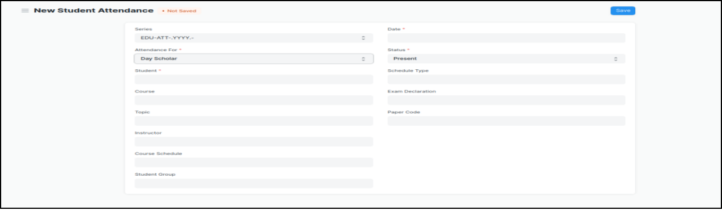

Figure 5 : Student Attendance Screen

**Field List:**

The following table describes the UI fields present in this screen :

|  |  |  |  |  |  |  |
| --- | --- | --- | --- | --- | --- | --- |
| **ID** | **Field Name** | **Field Type** | **Validation/Action** | **Mandatory** | **Remarks** | **R/N/D** |
| 1 | Student | Link Field | Value will be fetched from Student list, user will select. | Yes |  |  |
| 2 | Student Name | Read only | After selecting student id, this field will be  Automatically filled up. |  |  |  |
| 3 | Course Schedule | Link Field | Value will be fetched from course schedule list. |  |  | 1. Module Schedule |
| 4 | Student Group | Link Field | Value will be fetched from Student group list in which the student is present. |  |  |  |
| 5 | Date | Date | User will select the current date | Yes |  |  |
| 6 | Status | Dropdown | Options : Present, Absent, On Leave  User will select. | Yes |  |  |
| 7 | Reason | Long Text | If Status is On Leave, then reason field will be visible |  |  |  |
| 8 | Course | Link Field | Value will be fetched from Course list that the student have enrolled. User will select |  |  | ( R ) Module |

\*\***Note**:

* **The Attendance can be marked for the Exams and also the Student Attendance Tool can be used for bulk upgradation of the attendance.**
* **Reminder mail will be send after two week to the trainer and head of the department if an attendance is not marked for a particular class.**

**Users: Roles and Permissions**

The following table describes the users and their roles and permissions for the screens :

|  |  |  |  |  |  |  |  |  |  |
| --- | --- | --- | --- | --- | --- | --- | --- | --- | --- |
| **ID** | **Role** | **Select** | **Read** | **Write** | **Create** | **Delete** | **Submit** | **Cancel** | **Amend** |
| 1 | Admin | Yes | Yes | Yes | Yes | Yes | Yes | Yes | Yes |
| 2 | Instructor | Yes | Yes | Yes | Yes | Yes | Yes | Yes | Yes |
| 3 | Student | No | Yes | No | No | No | No | No | No |
| 4 | Hostel Admin | Yes | Yes | Yes | Yes | Yes | Yes | Yes | Yes |

## Student Leave Application

**General Description**

The following table describes overall information about this screen:

|  |  |
| --- | --- |
| **Description** | The Student Leave Application allows you to keep a track of leaves for a student. |
| **Navigation** | Home > Academics > Attendance and Leave Application > Student Leave Application |
| **Pre-requisites** | 1. Student  2. Student Group |

**Screenshot**

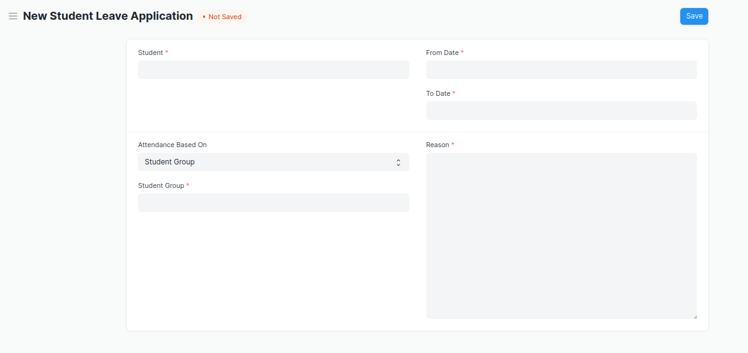

Figure 6 : Student Leave Application Screen

**Field List**

The following table describes the UI fields present in this screen :

|  |  |  |  |  |  |  |
| --- | --- | --- | --- | --- | --- | --- |
| **ID** | **Field Name** | **Field Type** | **Validation/Action** | **Mandatory** | **Remarks** | **R/N/D** |
| 1 | Student | Link Field | Value will be fetched from Student list.User will select. | Yes |  |  |
| 2 | Student Name | Read only | Value will be automatically filled up after selecting Student. |  |  |  |
| 3 | From Date | Date | User will select date | Yes |  |  |
| 4 | To Date | Date | User will select date | Yes |  |  |
| 5 | Total Leave Days | Float | User will give input |  |  |  |
| 6 | Attendance Based on | Dropdown | Options : Student Group,Course Schedule |  |  |  |
| 7 | Student Group | Link Field | Value will be the student group in which the student is present. |  |  |  |
| 8 | Course Schedule | Link Field | Value will be fetched from Course Schedule List,  User will select. | Yes |  | (R) Module Schedule |
| 9 | Reason | Text | User will give input. | Yes |  |  |
|  | Submit (Action Button) | | On submit Status button will be visible name as   1. Approved 2. Rejected 3. On hold   to the Class Advisor User |  |  |  |
|  | Approved | | If Class Advisor user will approved then the status will be Approved |  |  |  |
|  | Rejected | | If Class Advisor user will Reject then the status will be Rejected |  |  |  |
|  | On hold | | If Class Advisor user put in on hold status then he/she may further approved or rejected before the leave start date. |  |  |  |
|  |  | |  |  |  |  |

**\*\*Note: if the leave application is approved then, the attendance will be marked automatically\*\***

\*\***Note**: **Actions ( Approve , Reject , On Hold ) should trigger a mail to the student\*\***

**\*\*Note: Need to merge leave application form for hostel and academics into a single screen\*\***

**Users: Roles and Permissions**

The following table describes the users and their roles and permissions for the screens :

|  |  |  |  |  |  |  |  |  |  |
| --- | --- | --- | --- | --- | --- | --- | --- | --- | --- |
| **ID** | **Role** | **Select** | **Read** | **Write** | **Create** | **Delete** | **Submit** | **Cancel** | **Amend** |
| 1 | Admin | Yes | Yes | Yes | Yes | Yes | Yes | Yes | Yes |
| 2 | Instructor | No | Yes | Yes | No | Yes | Yes | No | No |
| 3 | Student | Yes | Yes | Yes | Yes | Yes | Yes | Yes | Yes |

## Mentor Allocation

**General Description**

The following table describes overall information about this screen:

|  |  |
| --- | --- |
| **Description** | Mentor Allocation is a process in which Mentors (Instructors) are allocated to different student groups or students on various basis. It can either be a hostel mentor allocation or program wise allocation. |
| **Navigation** | Home > Academics > Mentor-Mentee > Mentor Allocation |
| **Pre-requisites** | 1. Student 2. Instructor 3. Academic Year 4. Programs 5. Semester 6. Academic Term |

**Screenshot**

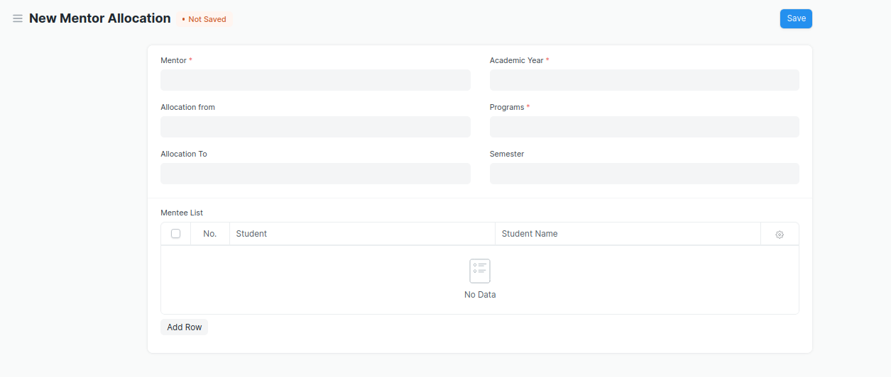

Figure 3 : Mentor Allocation screen

**UI List**

The following table describes the UI fields present in this screen :

|  |  |  |  |  |  |  |
| --- | --- | --- | --- | --- | --- | --- |
| **ID** | **Field Name** | **Field Type** | **Mandatory** | **Validation/Action** | **Remarks** | **R/N/D** |
| 1 | Mentor | Link Field | Yes | Value will be fetched from Employee List, User will select one |  |  |
| 2 | Mentor Name | Text |  | Value will be Filled up after selecting Mentor |  |  |
| 3 | Allocation From | Link Field |  | Value will be fetched from Academic Year  User will select one |  |  |
| 4 | Allocation To | Link Field |  | Value will be fetched from Academic Year  User will select one |  |  |
| 5 | Academic Year | Link Field |  | Value will be fetched from Academic Year  User will select one |  |  |
| 6 | Programs | Link Field | Yes | Value will be fetched from program list  User will select one |  | (R) Courses |
| 7 | Semester | Link Field |  | Value will be fetched from the program list, where a program is selected  User will select one |  |  |
| 8 | **Mentee List** | Child Table |  | User will add data in the child table |  |  |

|  |  |  |  |  |  |  |
| --- | --- | --- | --- | --- | --- | --- |
| **Mentee List** | | | | | | |
| **ID** | **Field Name** | **Field Type** | **Mandatory** | **Validation/Action** | **Remarks** | **R/N/D** |
| 1 | Student | Link Field |  | User need to select the students manually |  |  |
| 2 | Student Name | Text |  | After selecting student Id, Student Name will be automatically filled up |  |  |
| 3 | User | Text |  |  |  |  |
| 4 | Roll No | Text |  | After selecting student Id, roll number will be automatically filled up |  |  |

**Users: Roles and Permissions**

The following table describes the users and their roles and permissions for the screens :

|  |  |  |  |  |  |  |  |  |  |
| --- | --- | --- | --- | --- | --- | --- | --- | --- | --- |
| **ID** | **Role** | **Select** | **Read** | **Write** | **Create** | **Delete** | **Submit** | **Cancel** | **Amend** |
| 1 | Admin | Yes | Yes | Yes | Yes | Yes | Yes | Yes | Yes |
| 2 | Instructor | Yes | Yes | No | No | No | No | No | No |
| 3 | Student | Yes | Yes | No | No | No | No | No | No |

## Mentee Communication

**General Description**

The following table describes overall information about this screen:

|  |  |
| --- | --- |
| **Description** | 1. As in any relationship where information is being shared on an on-going basis, you and your mentees need to Interact and communicate effectively. 2. Communicating accomplishes three basic things - It is used to get things done, to indicate feelings and thoughts, and to develop the relationship. 3. In impersonal Interaction, a minimum of these three things are accomplished. But in a mentoring relationship, the communication process should accomplish all three tasks. |
| **Navigation** | Home > Academics > Mentor-Mentee > Communication |
| **Pre-requisites** | 1. Student  2. Mentor Allocation |

**Screenshot**

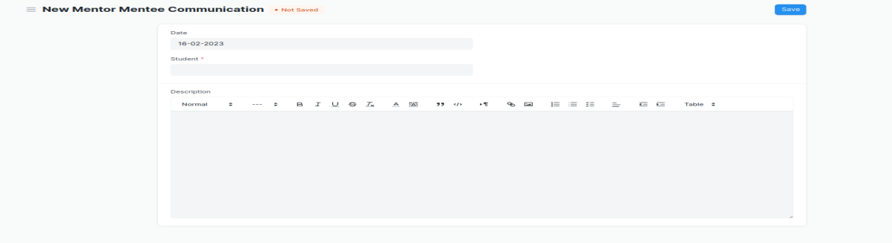

Figure 7 : Communication Screen

**Field List**

The following table describes the UI fields present in this screen :

|  |  |  |  |  |  |  |
| --- | --- | --- | --- | --- | --- | --- |
| **ID** | **Field Name** | **Field Type** | **Mandatory** | **Validation/Action** | **Remarks** | **R/N/D** |
| 1 | Date | Date |  | User will select Date |  |  |
| 2 | Student | Link Field | Yes | Value will be fetched from student list,User will select one. |  |  |
| 3 | Student Name | Text |  | After selecting student Id, Student Name will be automatically filled up |  |  |
| 4 | Programs | Link Field | Yes | Value will be fetched from program list.  User will select one. |  | ( R ) Courses |
| 5 | Mentor Allocation | Link |  | Value will be fetched from mentor allocation list.User will select one. |  |  |
| 6 | Mentor Name | Text |  | User will select the Mentor Name |  |  |
| 7 | Description | Text |  | user will add description |  |  |
| 8 | Student Disciplinary Complain | Link |  | Value will be fetched from Student Disciplinary Complain |  |  |

**Users: Roles and Permissions**

The following table describes the users and their roles and permissions for the screens :

|  |  |  |  |  |  |  |  |  |  |
| --- | --- | --- | --- | --- | --- | --- | --- | --- | --- |
| **ID** | **Role** | **Select** | **Read** | **Write** | **Create** | **Delete** | **Submit** | **Cancel** | **Amend** |
| 1 | Admin | Yes | Yes | Yes | Yes | Yes | NA | NA | NA |
| 2 | Instructor | Yes | Yes | Yes | Yes | Yes | NA | NA | NA |
| 3 | Admin | Yes | Yes | Yes | Yes | Yes | NA | NA | NA |
| 4 | Student | Yes | Yes | No | No | No | NA | NA | NA |

## Mentor Communication

**General Description**

The following table describes overall information about this screen:

|  |  |
| --- | --- |
| **Description** | In Mentor Communication, mentors or trainers can communicate with their respective students to share different information and other activities. |
| **Navigation** | Home > Academics > Mentor-Mentee > Mentor Communication |
| **Pre-requisites** | 1. Mentor Allocation   2. Student Group |

**Screenshot:**

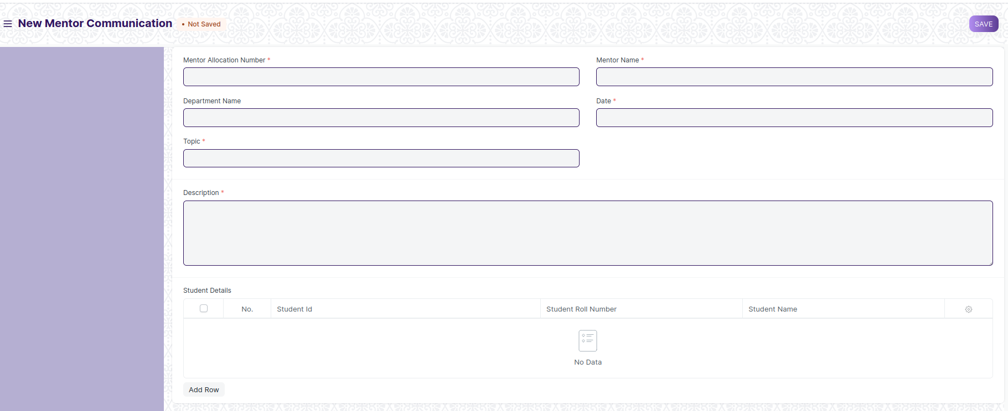

Figure 10 : Mentor Communication

**Field List**

The following table describes the UI fields present in this screen :

|  |  |  |  |  |  |  |
| --- | --- | --- | --- | --- | --- | --- |
| **ID** | **Field Name** | **Field Type** | **Mandatory** | **Validation/Action** | **Remarks** | **R/N/D** |
| 1 | Mentor Allocation Number | Link Field | Yes | Links with Mentor Allocation Screen |  |  |
| 2 | Mentor Name | Link Field | Yes | It will auto fetch when Mentor Allocation Number is entered |  |  |
| 3 | Department Name | Link Field |  | It will auto fetch when Mentor Allocation Number is entered |  |  |
| 4 | Date | Date | Yes |  |  |  |
| 5 | Topic | Text | Yes |  |  |  |
| 6 | Description | Long Text | Yes |  |  |  |
| 7 | **Student Details** | Table |  | This table is described below |  |  |
|  | Submit | |  | 1. On submit an email need to be triggered to all the students who are belongs to that particular mentor. 2. Or only those Students will be able to view the information from their respective mentors. |  |  |

|  |  |  |  |  |  |  |
| --- | --- | --- | --- | --- | --- | --- |
| **Student Details Table** | | | | | | |
| **ID** | **Field Name** | **Field Type** | **Mandatory** | **Validation/Action** | **Remarks** | **R/N/D** |
| 1 | Student ID | Link Field |  | Link Fields to Student Screen, students will auto fetched from Mentor Allocation Screen |  |  |
| 2 | Student Name | Text |  | Student Name Auto Fetched when data fetched in Student Id. |  |  |
| 3 | Student Roll Number | Text |  | Student Roll Number Auto Fetched when data fetched in Student Id. |  |  |

**Users: Roles and Permissions**

The following table describes the users and their roles and permissions for the screens :

|  |  |  |  |  |  |  |  |  |  |
| --- | --- | --- | --- | --- | --- | --- | --- | --- | --- |
| **ID** | **Role** | **Select** | **Read** | **Write** | **Create** | **Delete** | **Submit** | **Cancel** | **Amend** |
| 1 | Admin | Yes | Yes | Yes | Yes | Yes | NA | NA | NA |
| 2 | Instructor | Yes | Yes | Yes | Yes | Yes | NA | NA | NA |

## Assignment

**General Description**

The following table describes overall information about this screen:

|  |  |
| --- | --- |
| **Description** | In Assignment Screen Trainers can easily provide assignment to their respective students, so that it gives a strong bonding between the students and the trainers. |
| **Navigation** |  |
| **Pre-requisites** | 1. Instructor 2. Student Group |

**Screenshot**

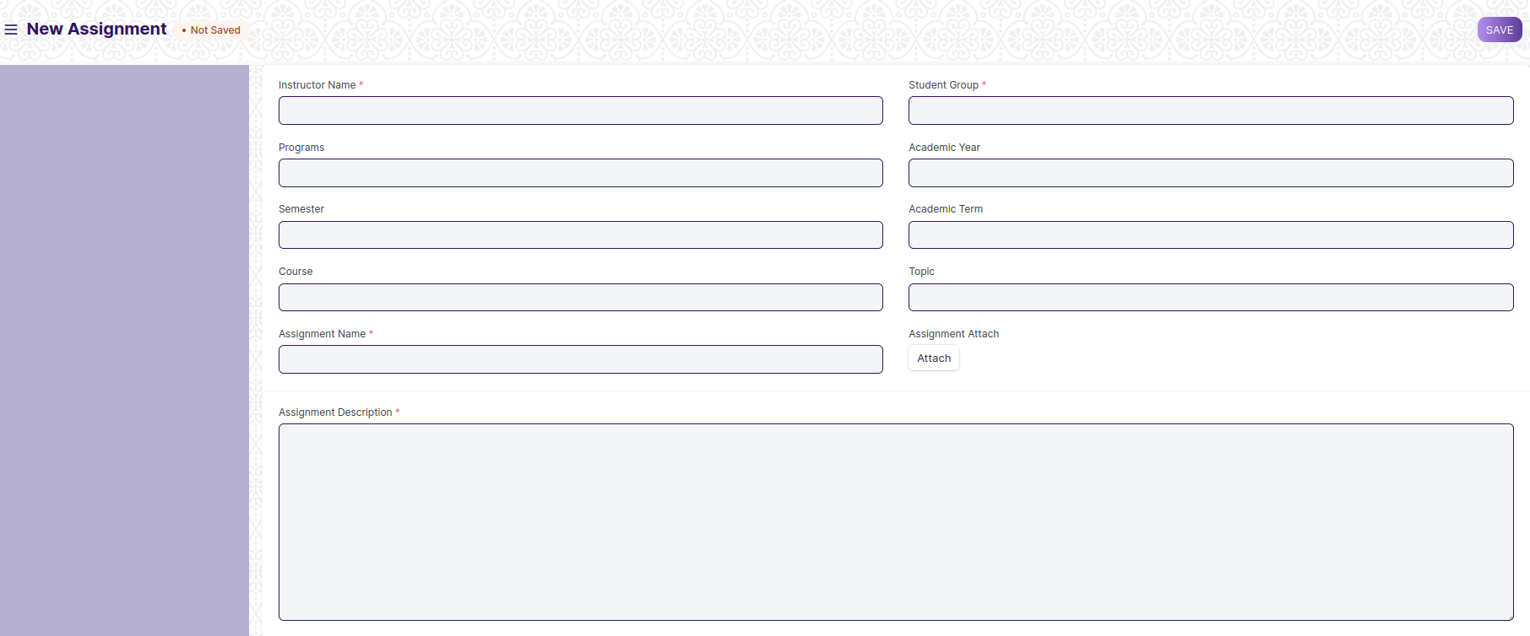

Figure 11 : Assignment Screen

**Field List**

The following table describes the UI fields present in this screen :

|  |  |  |  |  |  |  |
| --- | --- | --- | --- | --- | --- | --- |
| **ID** | **Field Name** | **Field Type** | **Mandatory** | **Validation/Action** | **Remarks** | **R/N/D** |
| 1 | Instructor Name | Link Field | Yes | Links with Instructor Screen, filters w.r.t Student Group |  |  |
| 2 | Student Group | Link Field | Yes | Links with Student Group Screen |  |  |
| 3 | Programs | Link Field |  | It will auto fetch when Student Group is entered, filters w.r.t Student Group |  | (R) Course |
| 4 | Semester | Link Field |  | It will auto fetch when Student Group is entered, filters w.r.t Student Group |  |  |
| 5 | Course | Link Field |  | It will auto fetch when Student Group is entered, filters w.r.t Student Group |  | (R) Module |
| 6 | Topic | Link Field |  | Links with Topic Screen and filters topics should come with respect to the above course field |  | (R) Sub Module |
| 7 | Assignment Name | Text |  | User Input |  |  |
| 8 | Assignment Attach Button | Attach |  | 1. On attachment a dialogue box will be popup where user can attach the files, images , takes the picture with the help camera and can link any URL.   If photos or images attached then the size will be maximum 200 kb. |  |  |
| 9 | Description | Long Text |  |  |  |  |
|  | Submit |  |  | On Submit the assignment will be able to visible only to their respective students. |  |  |

**Users: Roles and Permissions**

The following table describes the users and their roles and permissions for the screens :

|  |  |  |  |  |  |  |  |  |  |
| --- | --- | --- | --- | --- | --- | --- | --- | --- | --- |
| **ID** | **Role** | **Select** | **Read** | **Write** | **Create** | **Delete** | **Submit** | **Cancel** | **Amend** |
| 1 | Admin | Yes | Yes | Yes | Yes | Yes | NA | NA | NA |
| 2 | Instructor | Yes | Yes | Yes | Yes | Yes | NA | NA | NA |
| 3 | Student | No | Yes | No | No | No | NA | NA | NA |

## Assignment Upload

**General Description**

The following table describes overall information about this screen:

|  |  |
| --- | --- |
| **Description** | In Assignment Upload Screen Students can easily upload their assignment and it will securely go to their respective trainers. |
| **Navigation** |  |
| **Pre-requisites** | 1. Student Group 2. Assignment |

**Screenshot**

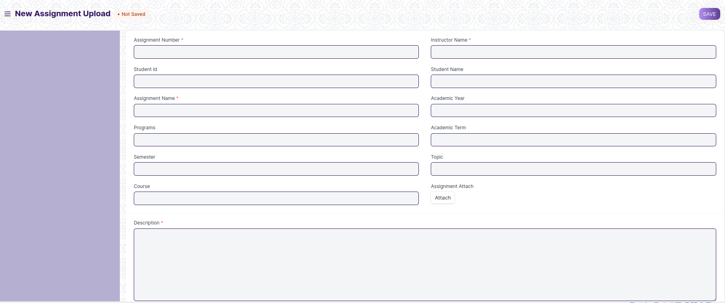

Figure 12: Assignment Upload

**Field Type**

The following table describes the UI fields present in this screen :

|  |  |  |  |  |  |  |
| --- | --- | --- | --- | --- | --- | --- |
| **ID** | **Field Name** | **Field Type** | **Mandatory** | **Validation/Action** | **Remarks** | **R/N/D** |
| 1 | Instructor Name | Link Field | Yes | Links with Instructor Screen |  |  |
| 2 | Assginment Number | Link Field | Yes | Links with Assignment Screen |  |  |
| 3 | Student Id | Link Field |  | Link with Student Screen |  |  |
| 4 | Student name | Text Field |  | It will auto fetch when Student Id is entered |  |  |
| 5 | Programs | Link Field |  | It will auto fetch when Student Id is entered |  | ( R ) Course |
| 6 | Semester | Link Field |  | It will auto fetch when Student Id is entered |  |  |
| 7 | Academic Year | Link Field |  | Link with Academic Year Screen |  |  |
| 8 | Academic Term | Link Field |  | Link with Academic Term and Value will be fetched based on selected Academic year. |  |  |
| 9 | Course | Link Field |  | It will auto fetch when Student Id is entered |  | ( R ) Module |
| 10 | Topic | Link Field |  | Links with Topic Screen and filters topics should come with respect to the course |  | (R) Sub Module |
| 11 | Assignment Name | Text | Yes | User Entered |  |  |
| 12 | Assignment Attach Button | Attach |  | 1. On attachment a dialogue box will be popup where user can attach the image, take the picture with the help camera and can link any URL. 2. If photos or images attached then the size will be maximum 200 kb. |  |  |
| 13 | Description | Long Text | Yes |  |  |  |
|  | Submit |  |  | On Submit assignment will be shown only to that particular instructor. |  |  |

**Users: Roles and Permissions**

The following table describes the users and their roles and permissions for the screens :

|  |  |  |  |  |  |  |  |  |  |
| --- | --- | --- | --- | --- | --- | --- | --- | --- | --- |
| **ID** | **Role** | **Select** | **Read** | **Write** | **Create** | **Delete** | **Submit** | **Cancel** | **Amend** |
| 1 | Admin | Yes | Yes | Yes | Yes | Yes | NA | NA | NA |
| 2 | Student | Yes | Yes | Yes | Yes | Yes | NA | NA | NA |